Group: **Learners.**

Members:

1. Varun Parekh - AU2040011
2. Vanshit Shah - AU2040098
3. Madhvendra Jhala - AU2040162
4. Ushmay Patel - AU2040253

**This week we have implemented our code on a different dataset than the one we used during previous week and tried to check the accuracy of the algorithm on different datasets.**

**Link of Google Colab:**

<https://colab.research.google.com/drive/1YgrpSzoJTn0B-zPDGSCm8EMwBQngw6qf?usp=sharing>

**Dataset - Drive Link:**

<https://drive.google.com/drive/folders/1dc3-UvjtcWzPj6ntPoKyVGeslK2qG0ac?usp=sharing>

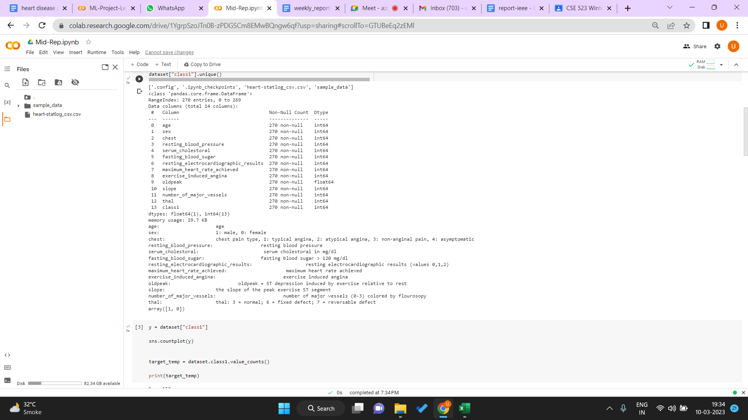

Age, sex, chest pain and its four types, resting blood pressure, cholesterol, fasting blood sugar, resting electrocardiographic results, maximum heart rate achieved , exercise induced angina, ST depression induced by exercise relative to rest, the slope of the peak exercise ST segment and the number of major vessels colored by fluoroscopy. These are the parameters on which we have worked.

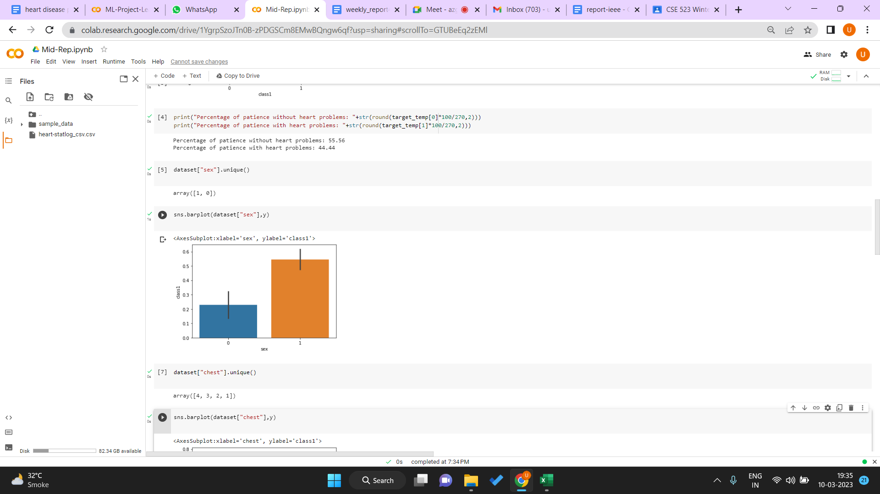This shows the percentage of patients with and without heart problems.

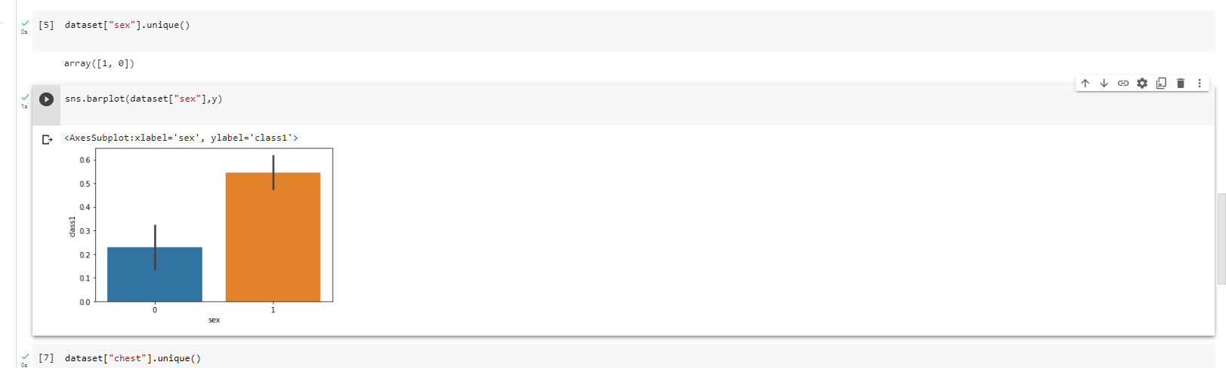

This denotes the sex percentage of our dataset.

(0→ female, 1→male)

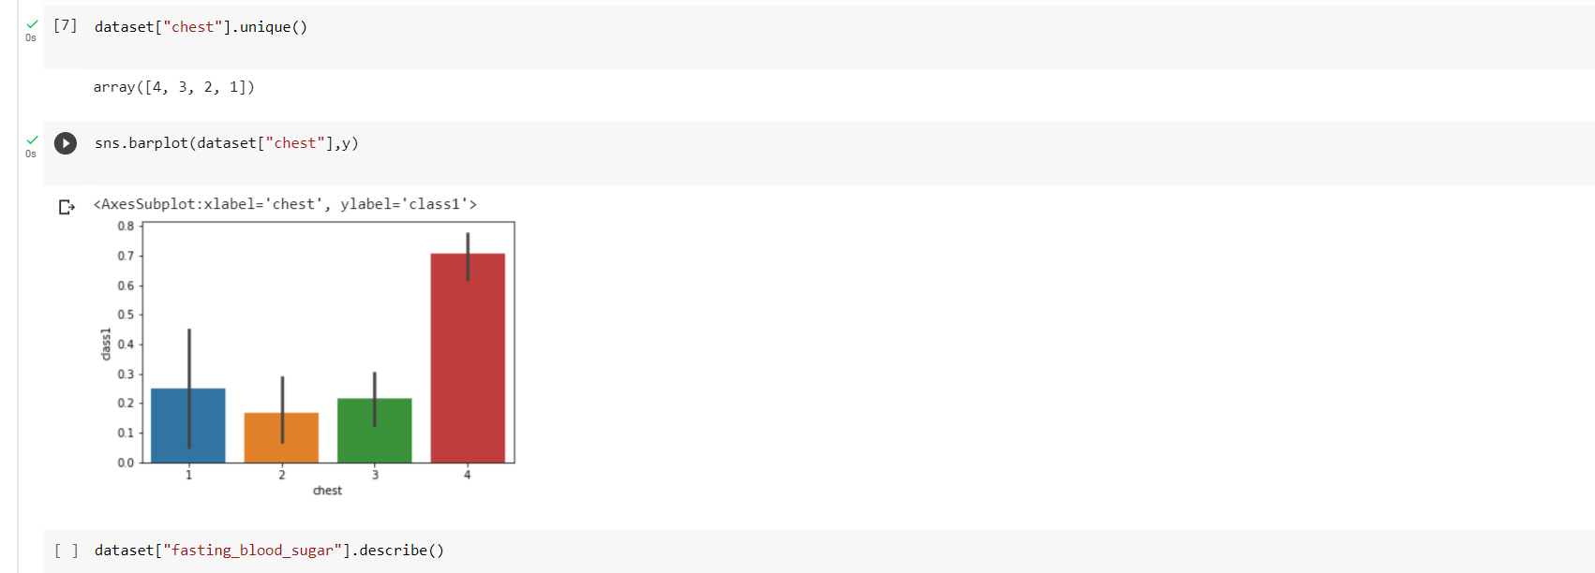

These are the 4 different types of chest pain.

1. Typical angina
2. Atypical angina
3. Non anginal pain
4. asymptomatic

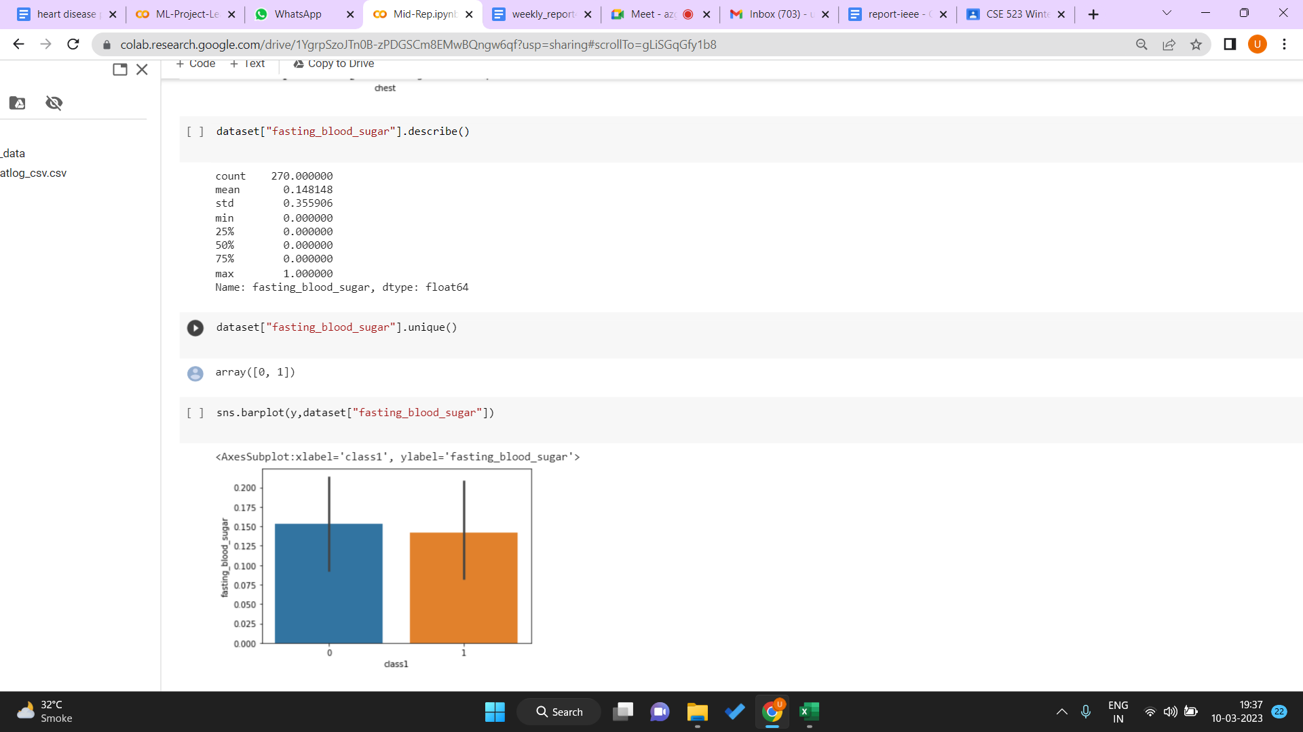

Fasting blood sugar

Summary of fasting blood sugar in our dataset and fasting blood sugar result.

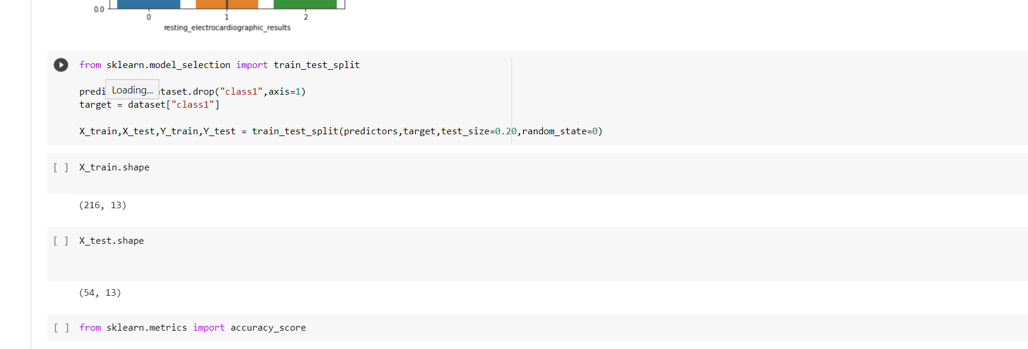

We have divided the data into 80% training set and 20% test set.

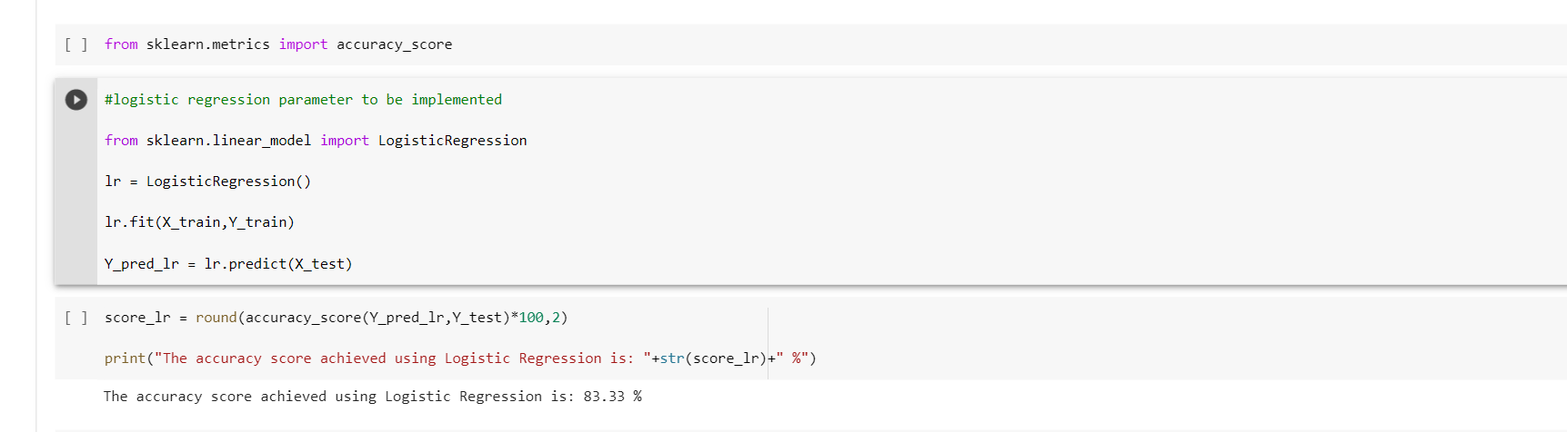

This is Logistic regression implementation.

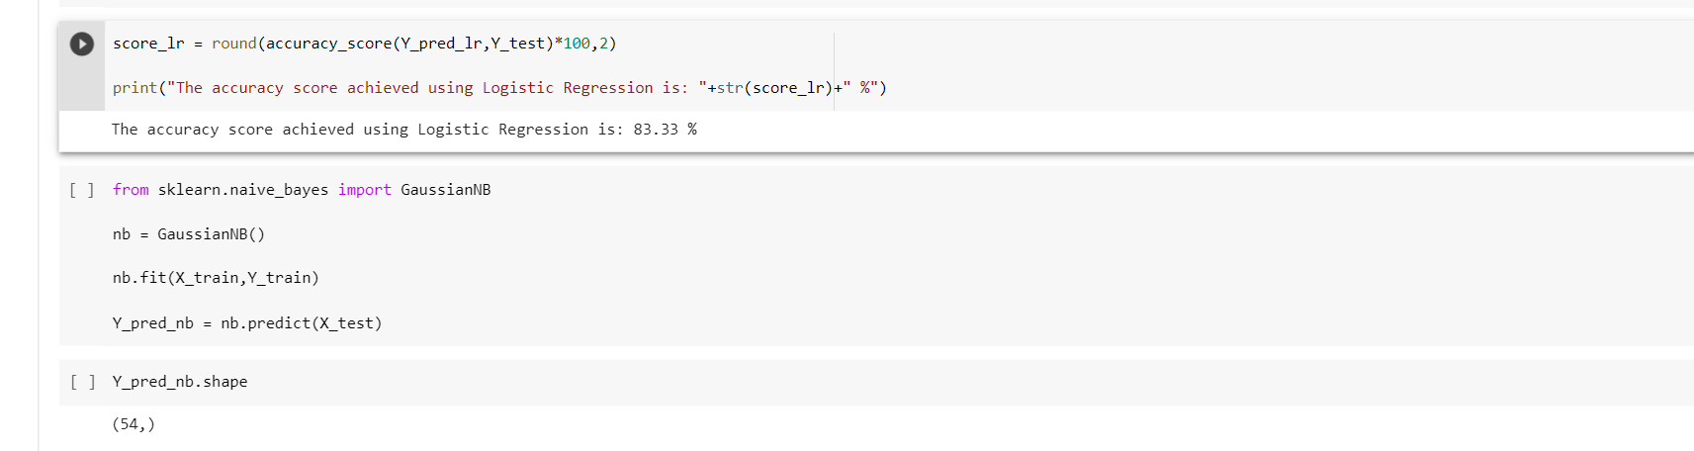

The accuracy achieved by logistic regression is **83.33%**

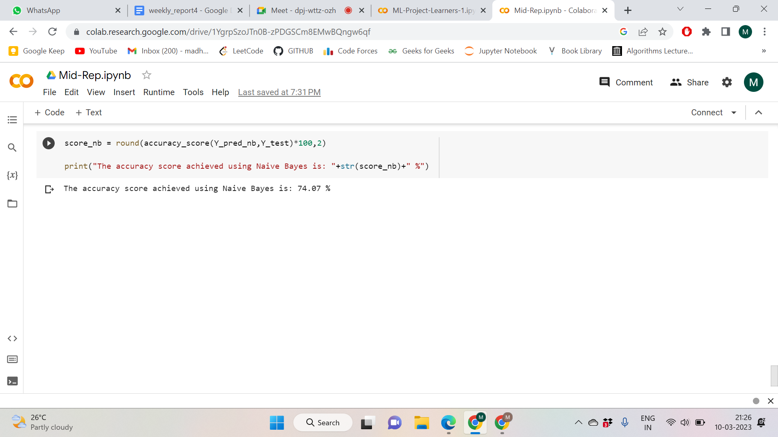

The accuracy obtained using Naive Bayes is: **74.87%**.